Name: Venkata Vamsi Siva Krishna Vura

LAB ASSIGNMENT-3

MASH UP

Done using the google maps and the twitter services.

In these I used the hurricane sandy tweets function predefined in the API

Mash up with google maps and the hurricane

Js Fiddle link is http://jsfiddle.net/cB97A/4/

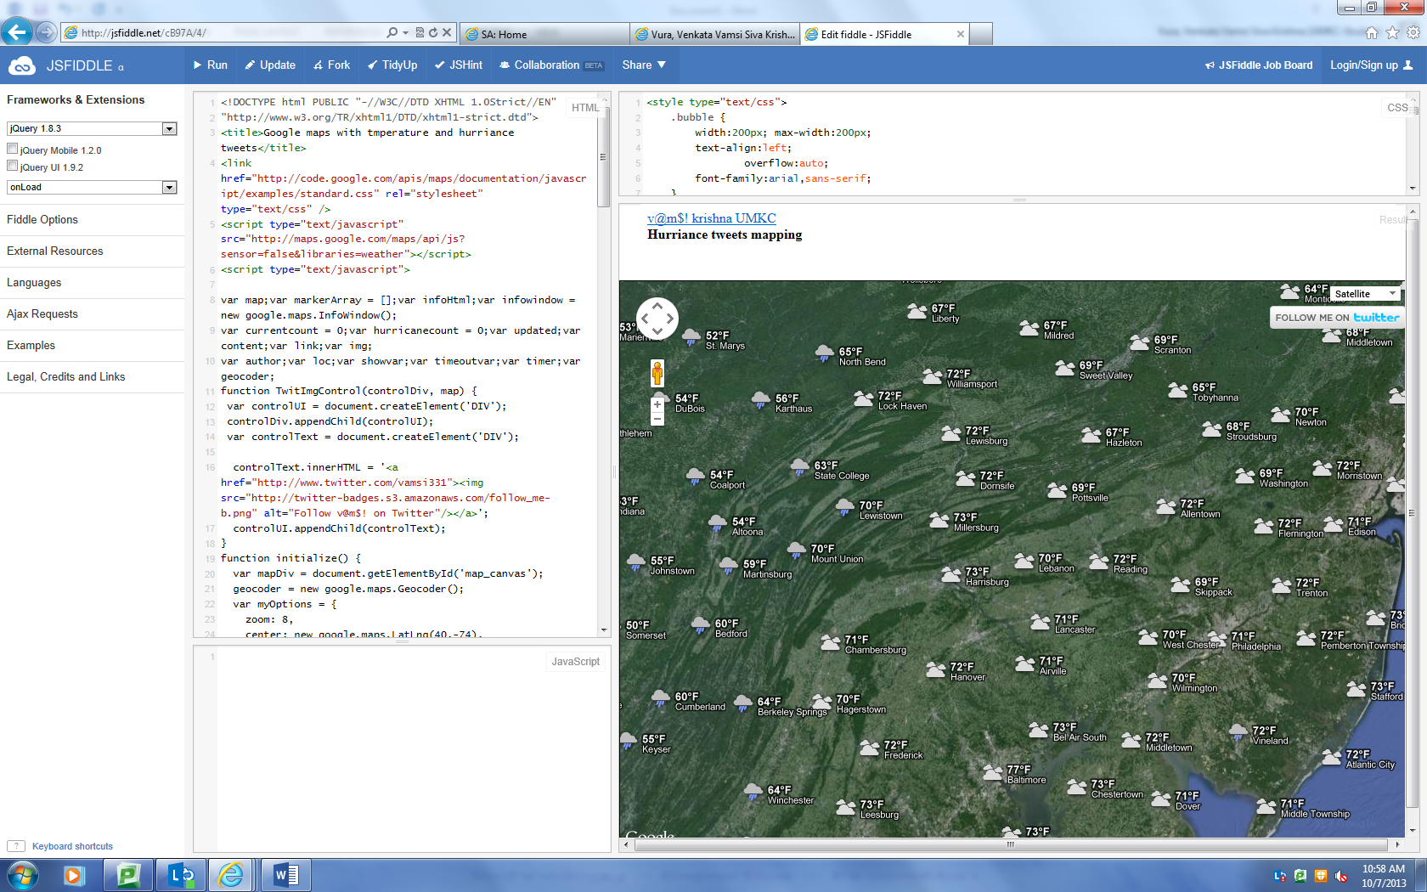

We are able to know the temperature at the particular location by clicking on the cloud symbol

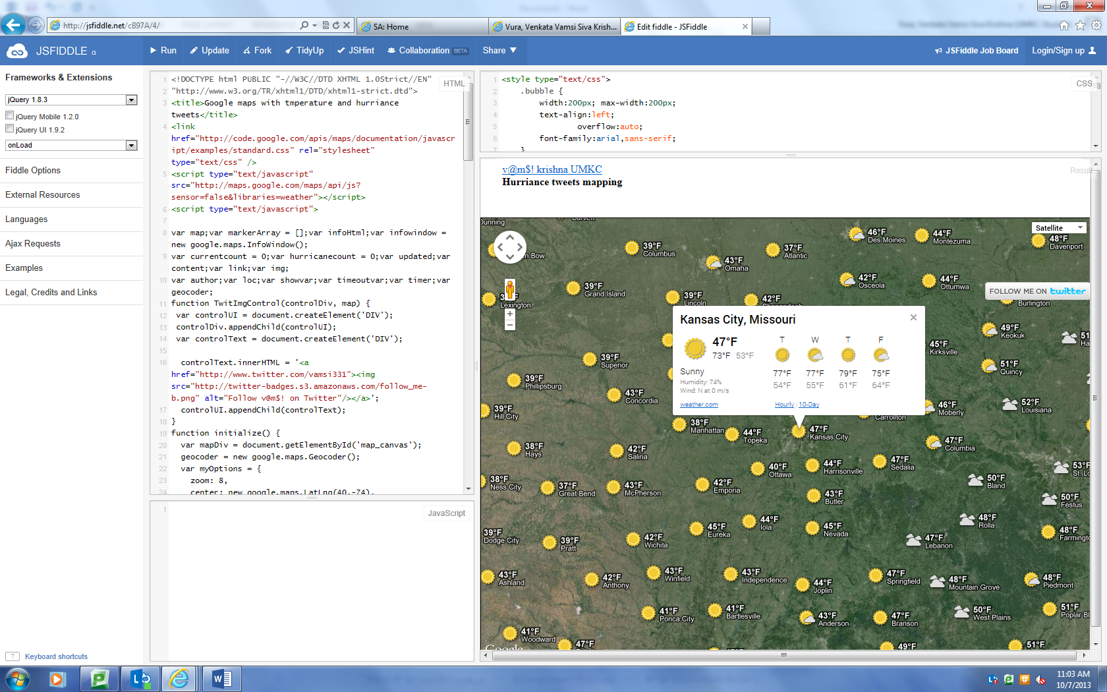

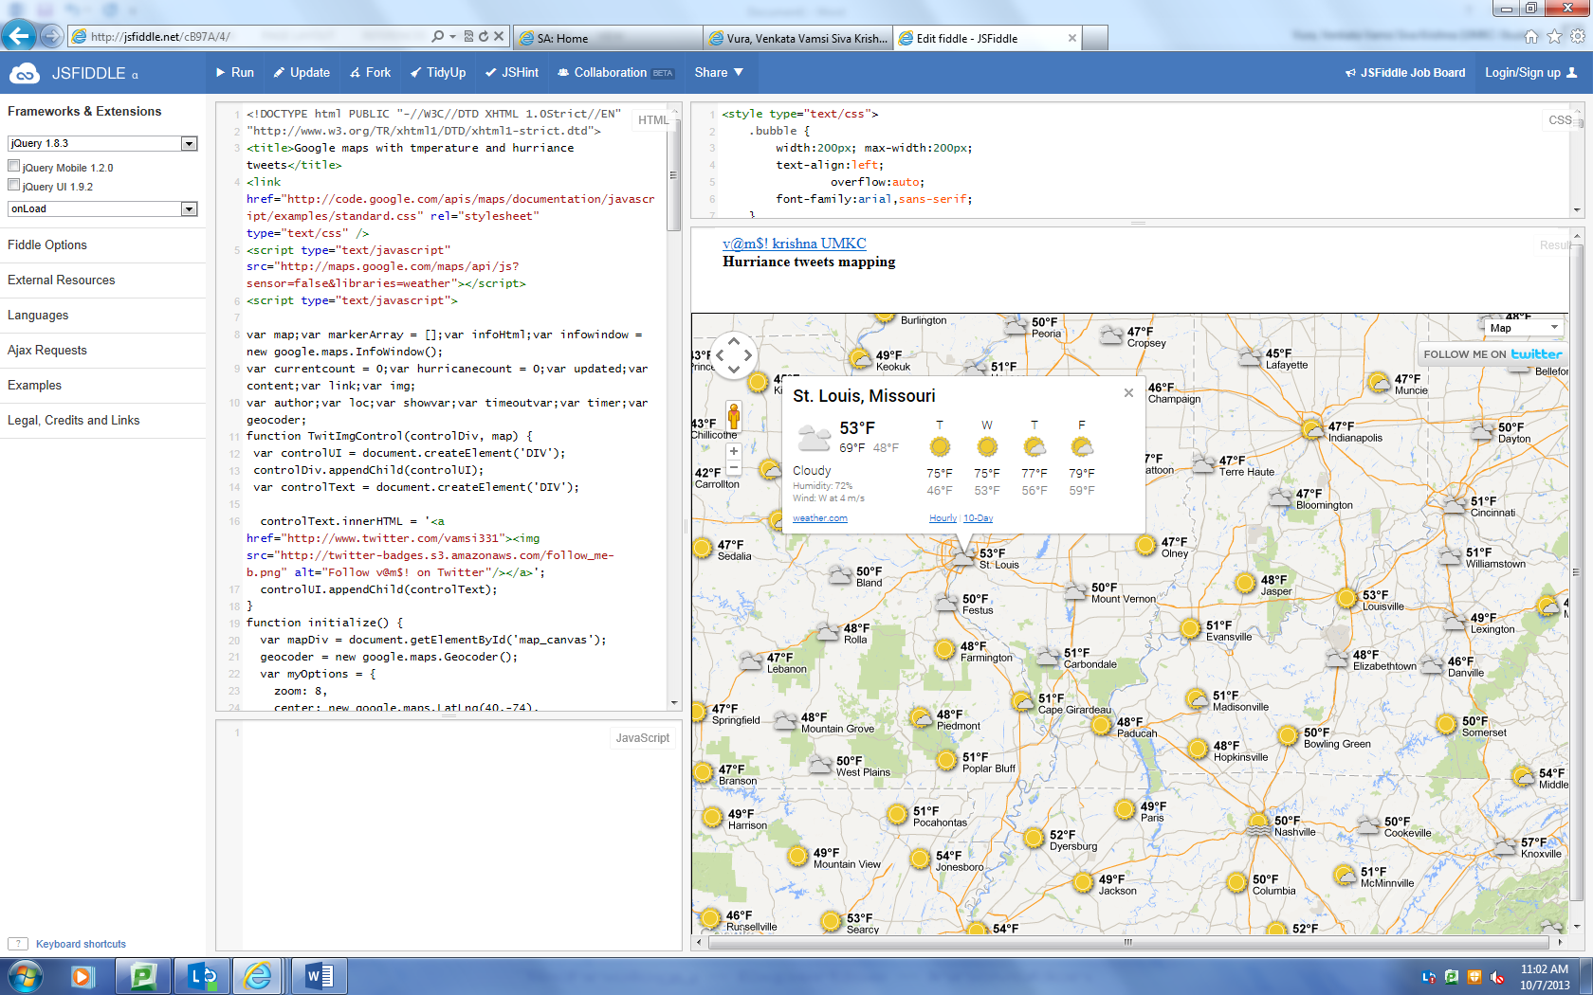

By clicking on the twitter link on the right corner we are able to open the twitter

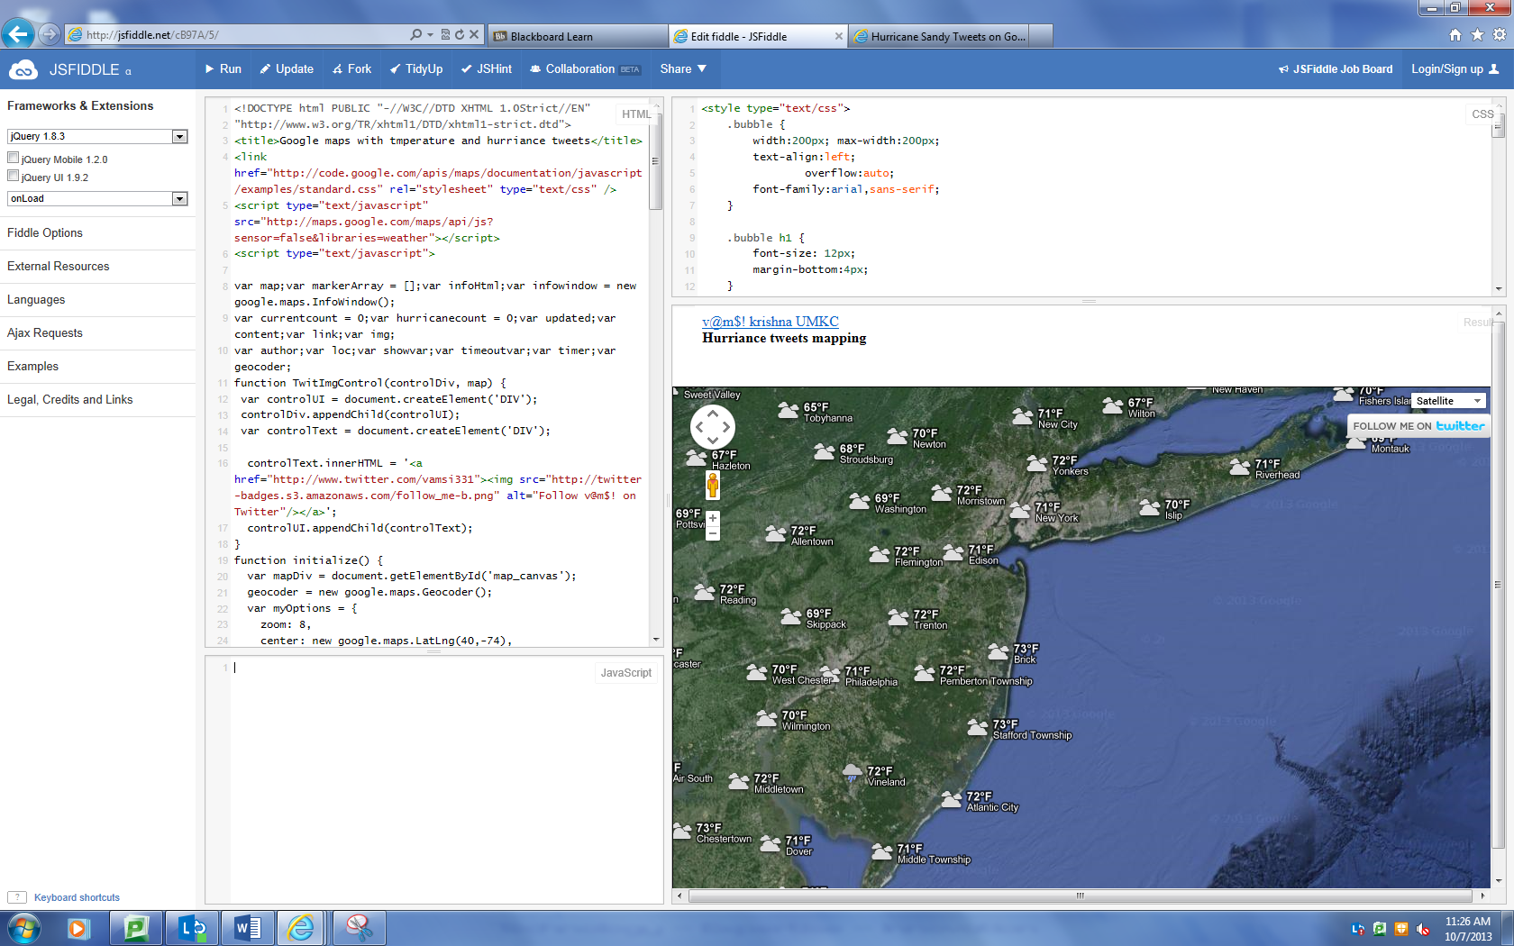

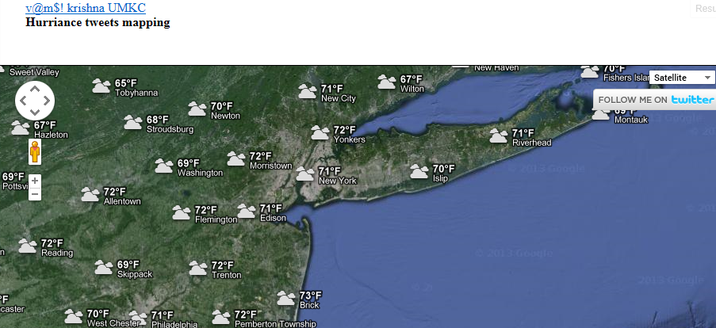

By pressing the twitter it is displaying the message to open in a new window after that it shows vamsi331 twitter page

